

*S*tar Shipping busy carrying project cargo from Port Qasim – Pakistan

**NEWS BULLETIN**

**STAR SHIPPING PAKISTAN**

www.starship.com.pk

Star Shipping Pakistan has done a Project movement of a Compressor & Cooler with accessories from Port Qasim to the Daharki Project Site, recently.

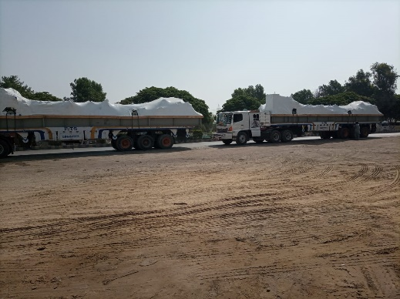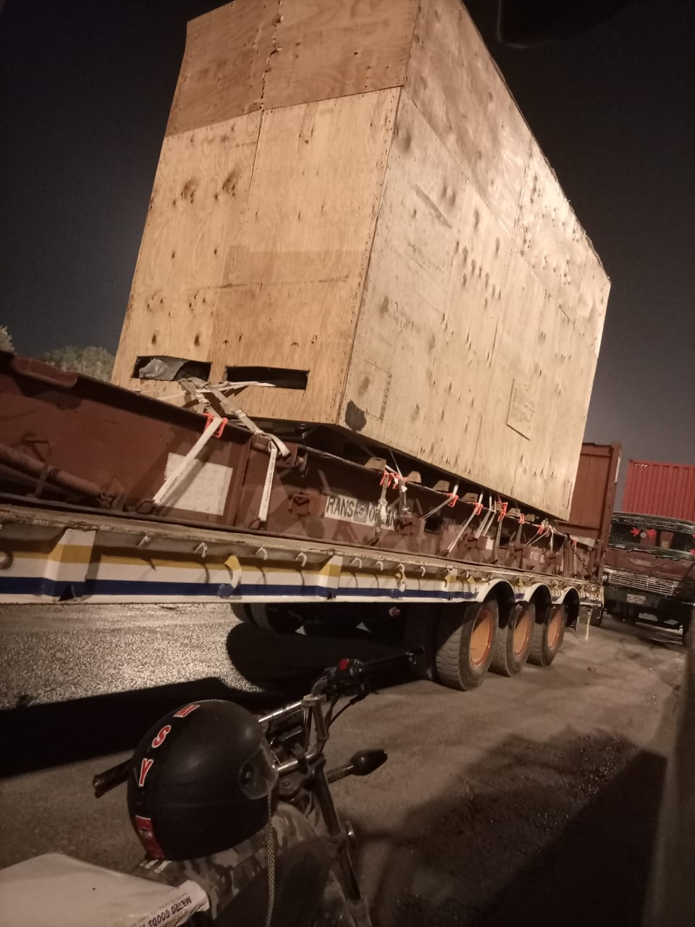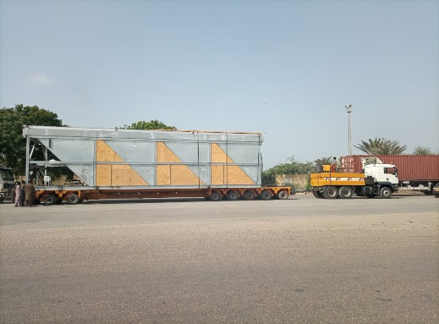Shipment specifications:

Compressor

* L 18 M
* W .5.18 M
* H 5.44 M
* Weight 50 Ton

Cooler

* L 14.32 M
* W 2.4384
* H 2.7432
* Weight 30 Ton
* Loading Port: Houston USA
* Discharging Port: Port Qasim
* Delivery Final Site: Daharki – Sindh

Multi-Axle & Multiple low beds & flatbeds along with a heavy-duty mobile hydraulic crane were utilized to lift this project. There were few challenges in transit which were obtaining the road permissions, wildlife and dry weather. Hence the job was done successfully and the Cargo delivered in safe & sound condition.

Our operations team and all the other workforce remained safe and secured.